|  |  |  |  |  |  |  |
| --- | --- | --- | --- | --- | --- | --- |
| **课程名称** | | **Web前端开发** | | | | |
| **作业名称** | | **CSS课堂练习** | | | | |
| **姓名** | 卓如意 | | **学号** | 22145138 | **班级** | 计算机科学与技术221 |

* 内容与要求：

1. 具体内容和素材见附件，《css手册4.2.3.chm》是学习和作业时参考资料。
2. 本次练习完成Jane Shopping网站首页CSS样式代码**。**
3. 页面要求和说明详见ppt文件《第8章 CSS综合案例》
4. 完成后将代码复制粘贴到本文档中，预览效果图截图粘贴到本文档中。
5. 复制到文档中的代码只需要CSS部分，截图不要全屏截图，使用局部截图。
6. 网站上需提交本文档与源代码压缩包。
7. images文件中是图片素材。

* 源代码与效果截图

代码base.css

* {

margin: 0;

padding: 0;

word-wrap: break-word;

word-break: break-all;

}

body {

background: #fff;

color: #333;

font: 12px/1.6em Arial, sans-serif;

}

a {

color: #0287CA;

text-decoration: none;

}

a:hover {

text-decoration: underline;

}

ul,

li {

list-style: none;

}

img {

border: none;

}

h1,

h2,

h3,

h4,

h5,

h6 {

font-size: 1em;

}

html {

overflow: -moz-scrollbars-vertical;

}

代码header.css

#header {

width: 800px;

height: 80px;

border: 1px solid #AAA;

margin: 10px auto;

background: #3B5998;

}

#logo {

float: left;

margin: 0 0 0 10px;

color: #FFF;

font-size: 3em;

font-weight: 700;

line-height: 80px;

}

#skin {

float: left;

margin: 10px;

padding: 4px;

width: 120px;

list-style: none;

border: 1px solid #cccccc;

background: #FFF;

}

#skin li {

float: left;

margin-right: 4px;

width: 15px;

height: 15px;

text-indent: -9999px;

overflow: hidden;

display: block;

cursor: pointer;

background-image: url("../images/theme.gif");

}

#skin_0 {

background-position: 0px 0px;

}

#skin_1 {

background-position: 15px 0px;

}

#skin_2 {

background-position: 35px 0px;

}

#skin_3 {

background-position: 55px 0px;

}

#skin_4 {

background-position: 75px 0px;

}

#skin_5 {

background-position: 95px 0px;

}

#skin_0.selected {

background-position: 0px 15px;

}

#skin_1.selected {

background-position: 15px 15px;

}

#skin_2.selected {

background-position: 35px 15px;

}

#skin_3.selected {

background-position: 55px 15px;

}

#skin_4.selected {

background-position: 75px 15px;

}

#skin_5.selected {

background-position: 95px 15px;

}

代码nav.css

#navigation {

width: 784px;

padding: 8px;

margin: 8px auto;

background: #3B5998;

height: 18px;

}

#navigation ul li {

float: left;

margin-right: 14px;

position: relative;

z-index: 100;

}

#navigation ul li a {

display: block;

padding: 0 8px;

background: #EEEEEE;

font-weight: 700;

}

#navigation ul li a:hover {

background: none;

color: #fff;

}

#navigation ul li ul {

background-color: #88C366;

position: absolute;

width: 80px;

overflow: hidden;

display: none;

}

#navigation ul li:hover ul {

background-color: #88C366;

position: absolute;

width: 100px;

display: block;

}

#navigation ul li ul li {

border-bottom: 1px solid #BBB;

text-align: left;

width: 100%;

}

代码index.css

#content {

margin: 10px auto;

width: 800px;

}

.content_left {

background: #eee;

border: 1px solid #AAAAAA;

width: 200px;

float: left;

margin-right: 10px;

}

.global_module {

position: relative;

background: #EEEEEE;

padding-bottom: 8px;

}

.module_up_down {

position: absolute;

top: 9px;

right: 10px;

cursor: pointer;

}

.global_module h3 {

height: 26px;

background: #3B5998;

color: #FFF;

line-height: 26px;

text-indent: 6px;

}

.content_left .news ul {

padding: 5px 0 5px 15px;

}

.content_left .procatalog ul {

padding: 5px 0 5px 15px;

}

.content_left .scrollNews {

width: 200px;

height: 85px;

line-height: 20px;

overflow: hidden;

background: #FFFFFF;

}

.content_left .scrollNews li {

height: 20px;

}

.procatalog .m-treeview {

background: #FFFFFF;

}

.procatalog .m-treeview li span {

cursor: pointer;

}

.procatalog .m-treeview li.m-expanded {

padding-left: 16px;

background: url('../images/treeview-expanded.gif') no-repeat 0 0;

}

.procatalog .m-treeview li.m-expanded ul li {

list-style-image: url('../images/treeview-item.gif');

}

.procatalog .m-treeview li.m-collapsed {

padding-left: 16px;

background: url('../images/treeview-collapsed.gif') no-repeat 0 0;

}

.procatalog .m-treeview li.m-collapsed ul {

display: none;

}

.content_right {

background: #eee;

border: 1px solid #AAAAAA;

width: 586px;

float: left;

}

.content_right .ad {

margin-bottom: 10px;

width: 586px;

height: 150px;

overflow: hidden;

position: relative;

}

.content_right .slider,

.content_right .num {

position: absolute;

}

.content_right .slider li {

list-style: none;

display: inline;

}

.content_right .slider img {

width: 586px;

height: 150px;

display: block;

}

.content_right .num {

right: 5px;

bottom: 5px;

}

.content_right .num li {

float: left;

color: #FF7300;

text-align: center;

line-height: 16px;

width: 16px;

height: 16px;

font-family: Arial;

font-size: 12px;

cursor: pointer;

overflow: hidden;

margin: 3px 1px;

border: 1px solid #FF7300;

background-color: #fff;

}

.content_right .num li.on {

color: #fff;

line-height: 21px;

width: 21px;

height: 21px;

font-size: 16px;

margin: 0 1px;

border: 0;

background-color: #FF7300;

font-weight: bold;

}

.content_right .prolist {

position: relative;

height: 220px;

margin-bottom: 10px;

overflow: hidden;

border: 1px solid #AAAAAA;

background: #FFFFFF;

}

.content_right .prolist .prolist_content {

position: absolute;

width: 1800px;

top: 26px;

left: 0px;

padding: 20px 0 0 8px;

}

.content_right .prolist ul {

margin-bottom: 10px;

float: left;

height: 220px;

}

.content_right .prolist ul li {

float: left;

display: inline;

text-align: center;

margin-right: 22px;

}

.content_right .prolist ul li span {

display: block;

overflow: hidden;

}

.content_right .prolist ul li img {

display: block;

width: 124px;

height: 124px;

background: #EEE;

border: 0;

}

.module_left_right {

position: absolute;

top: 5px;

right: 10px;

cursor: pointer;

}

#tooltip {

position: absolute;

border: 1px solid #333;

background: #f7f5d1;

padding: 1px;

color: #333;

display: none;

}

span.imageMask {

background: white;

filter: alpha(opacity=0);

-moz-opacity: 0;

-khtml-opacity: 0;

opacity: 0;

}

span.imageOver {

background: url(../images/zoom.gif) no-repeat 50% 50%;

filter: alpha(opacity=60);

-moz-opacity: 0.6;

-khtml-opacity: 0.6;

opacity: 0.6;

}

页面效果图

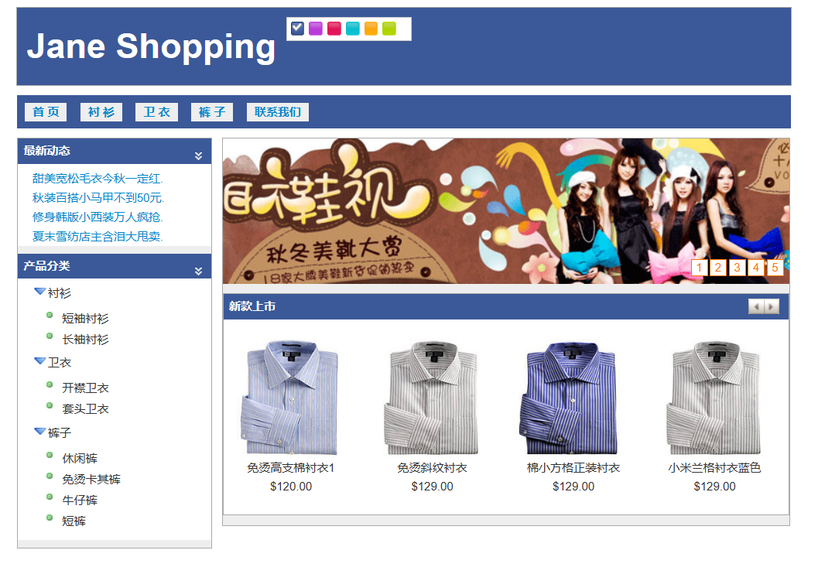

* 教师批阅